From the desk
July 26th, 2022
Dear Branch Presidents and Members,
Here is the latest news from the Board.
Shadow Judging
Why participate in Shadow judging?
Shadow Judging provides students with the framework to deeply discuss and review books from the CBCA shortlist. Funded student groups receive a set of 6 books and a visit from either a children’s illustrator or author. There are a variety of group sizes from small to a whole class. Anyone (up to and including 18-year-olds) can participate and the $50 SJ membership allows you to access all the SJ resources.
This year, I have been involved in the SJ program and have witnessed the detailed discussions by grade 5 students about the 6 shortlisted picture books. I found the 4 discussion questions recommended by Alyson Simpson (Sydney University) in the ‘Talking About Books’ films in the Shadow Judging resources were of great benefit and can be used in a wider school context.
Remember that participating groups need to have their 1 vote entered by Friday, July 29th 12:00 midnight. SJ groups can continue their discussions and upload their creative responses until August 26th.
Make time with your group to watch the Story Box Library film, announcing the first National CBCA Shadow Judges Choice Awards on Friday, August 26th at 12:00 midday AEST and discover the student choice winners.

Check out the Shadow Judging website https://shadowjudging.cbca.org.au
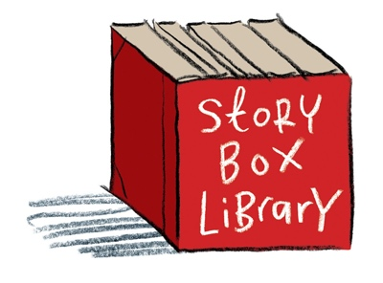
What the CBCA Partnership with Story Box Library offers you.
SBL have created the Book of the Year film, which announces the CBCA winner and honour books for 2022. Join in with your students on Friday, August 19th at 12:00 midday AEST to view the exciting results.
SBL have organized Book Week resources, including readings of many of the shortlisted books and book activities (available to SBL members).
SBL is celebrating amazing Australian children’s literature and the CBCA is excited to be in partnership with such a creative company.
Build up your skills with the University of Sydney Partnership
The University of Sydney has partnered with CBCA to present a 4-week education program (non-award) that will support the 2023 Sun Project (Shadow Judging), through recognising, investigating and responding to quality children’s literature. The program will introduce participants to the titles from the five categories of the CBCA 2023 Book of the Year Awards. This course supports teachers and other educators in leading student book discussions with their students.
2022 Merchandise- Buy now, we’re selling out

2022 merchandise has been highly successful and Jasmine Seymour’s artwork inspired record-breaking sales but the CBCA eStore will no longer be placing backorders (except for the Artisan Range). Therefore, when stocks run out, they will not be replaced. Please check the eStore for current stock and we will try to fulfill any orders as quickly as possible. Remember all sales benefit both the CBCA and individual branches.

2023 Merchandise- be prepared for another great range of CBCA merchandise
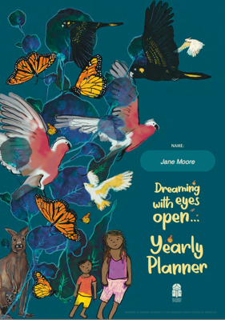
The CBCA merchandise subcommittee are already finalising the artwork for the 2023 merchandise range. The 2023 artist and theme will be announced after the 2022 CBCA Book Week. There are new products to be launched and CBCA members will again receive free digital items as part of their 2023 Branch membership.
One of the 2022 success stories has been the CBCA Yearly Planner full of information and ideas to run a children’s literature and literacy program throughout the year. They are still being purchased!
An even better CBCA Yearly Planner, featuring the 2023 artwork, is being developed for next year. More information will be available soon and early orders can be placed before the end of the year.
‘Zart Art’ (https://www.zartart.com.au) and ‘Learn From Play’ (https://learnfromplay.com) are 2 organisations that are contributing exclusive ideas to the 2023 CBCA Yearly Planner. Both organisations have great resources to support Book Week and the CBCA Notable/Shortlist books.

Royal Australian Mint- 2022 coin, ‘Diary of a Wombat’
In 2022, the Royal Australian Mint and CBCA celebrates the 20th Anniversary of ‘Diary of a Wombat’, written by Jackie French and illustrated by Bruce Whatley, with a special coin release in August.
For more information visit eshop.ramint.gov.au

Strategic Plan
CBCA is reviewing their strategic plan and a meeting will be planned this year for all Branch Presidents to attend and have their say. Please ensure your committee and members have had an opportunity to discuss the current strategic plan and suggest changes and recommendations.
2022 FFLL Symposium
#WeAllLoveAGoodStory
Another reminder about the Foundation for Learning and Literacy Symposium, 13 like-minded associations have joined together to advocate for the power and pleasure of literature in the development of literacy. CBCA will be presenting one of these free sessions later in the year (started June 8th and concludes mid-November).
Program dates, details and registration can be found at the Foundation For Learning and Literacy's Symposium website: https://foundationforlearningandliteracy.info/symp-home/
The next National Board Meeting will be on August 15th, 2022
Wendy Rapee (CBCA Chair) has returned from her overseas trip and will again be writing the ‘From the Desk’ in the future.
Happy Book Week preparations to you all.
Regards
Jane Moore (CBCA Deputy Chair, CBCA SA Director)

